General Biology Year 11

Unit 2 – Solving problems to survive

Task 7: Practical – Gas exchange in animals

MARKING KEY

|  |  |  |  |
| --- | --- | --- | --- |
| **Name:** | **Teacher:** | **Date:** | **Score:**  / **21** |

**Assessment type:** Science Inquiry - Practical

**Conditions**

Time for the task:

* **One hour in class assessment** – Dissect fish gills and make comparisons with a rat’s lungs.

**Task weighting** – 5%

______________________________________________________________________________

**Introduction:**

With few exceptions, oxygen is a requirement of most living things. Oxygen is a reactant in the process of aerobic respiration.

**glucose + oxygen → carbon dioxide + water + usable energy**

Animals use different mechanisms to obtain oxygen from their environment. The respiratory system is a system by which oxygen is obtained from the environment and brought into close contact with the cells or a transport system.

**Aim -** In this activity you will compare the way a fish and a rat obtain oxygen from the environment.

**PART A:** **The fish**

1. The fish you will examine is described as a ‘bony’ fish. Examine the external structure of the head of the fish. Identify the structures shown in the diagram below. Locate the **operculum**, lift it and look at the gills.



What do you think is the function of the operculum? (1 mark)

__________________________________________________________________________________________________________________________________________________

It protects the gills.

1. Cut out a small piece of gill and float it in a petri dish of water.

Describe what happened when you floated the piece of gill in the water? (1/2 mark) __________________________________________________________________________________________________________________________________________________

The gill has spread out. The water has separated the filaments.

What does this tell you about the structure of the gill? (1 mark)

__________________________________________________________________________________________________________________________________________________

It is made up of small filaments to increase the SA:VoL

1. With the **operculum** open, insert a blunt probe into its opening and determine where the cavity ends.

What **colour** were the gills of your fish? Suggest a **reason** for this colour. (1 mark)

__________________________________________________________________________________________________________________________________________________

Red. Lots of thin blood vessels indicating oxygenated blood present.

1. Refer to the fish video on the board. Observe a goldfish in a **fish tank**.

Describe the movement of the mouth and the operculum. (1 mark)

__________________________________________________________________________________________________________________________________________________

The movements of the mouth and operculum produce a stream of water, in through the mouth and over the gills and out of the operculum.

When the fish closes it mouth, where does the **water** go? (1/2 mark)

__________________________________________________________________________________________________________________________________________________

Over the gills and out the opercalum.

1. Remove a single gill. Examine the gill under a hand lens or binocular microscope to see the structure in more detail.

Draw a **labelled diagram** of **one gill** of a fish in the box below. (3 marks)

Pencil, correct diagram, no shading, sharp lines, labels (>=2)

(½ mark each)

1. Why do you think fish have **numerous flattened epithelial surfaces** (gill filaments)?

(1 mark)

__________________________________________________________________________________________________________________________________________________

To increase SA:Vol.

1. Describe how gills absorb oxygen and disperse carbon dioxide. (2 marks)

____________________________________________________________________________________________________________________________________________________________________________________________________________________________________________________________________________________________________

The water enters the mouth and passes through the feathery filaments of the fish's gills, which are rich in blood (1). These gill filaments absorb oxygen from the water and move it into the bloodstream (1/2). At the same time, waste carbon dioxide in the blood passes out through the gills into the water (1/2).

**PART B:** **The rat**

1. Study the rat dissection pictures below and answer the questions that follow.



The most obvious organs will be the heart and the lungs. Examine the lungs. Lungs in a living rat or freshly killed specimen would be bright red and have a spongy texture.

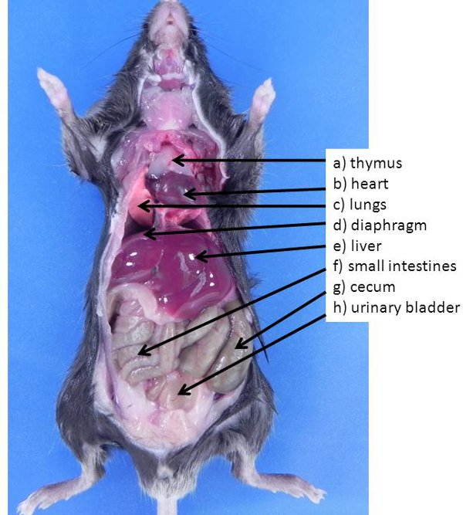

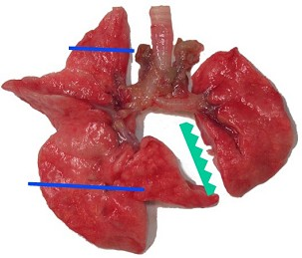

**Questions**

1. Often the lungs of mammals look like two balloons. Does this **description fit the shape** and structure of the rat’s lungs? Describe the structure of the lungs. (2 marks)

___________________________________________________________________________________________________________________________________________________________________________________________________________________________

The lungs are a pair of spongy, air-filled organs located on either side of the chest (thorax) (1). The trachea (windpipe) conducts inhaled air into the lungs through its tubular branches, called bronchi (1).

1. The lung tissue is made up of tiny air-filled sacs, the alveoli with walls which are one cell thick. Oxygen inhaled by the rat passes across these walls into blood capillaries.

Draw a **labelled diagram** of the lungs of a rat in the box below. (2 marks)

right lung left lung trachea bronchi

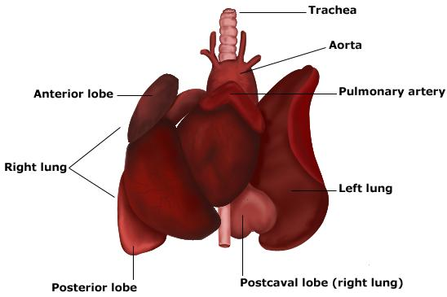

Pencil, sharp lines ½ each (max 1 mark)

Labels – 2 labels ½ mark (max 1 mark)

1. What do you think is the **function** of the trachea? (1 mark)

__________________________________________________________________________________________________________________________________________________

To take air to the alveoli (air sacs)

1. The interior surface of the trachea is **spongy-looking**. This is due to the lining of the trachea, which consists of column-shaped cells which secrete **mucus** (slippery secretion) and have many **cilia** (hair like structure) along their surface (see diagram below).

1. Suggest a **function** for the **cartilage** in the **trachea**. (1 mark)

__________________________________________________________________________________________________________________________________________________

The **tracheal** cartilages help support the **trachea** while still allowing it to move and flex

during breathing (strong and flexible).

1. What is the function of the **cilia**? (Hint – they beat upwards). (1 mark)

__________________________________________________________________________________________________________________________________________________

Move microbes and debris up and out of the airways.

1. Complete the table below. (3 marks)

½ mark each

|  |  |  |
| --- | --- | --- |
|  | **Fish** | **Rat** |
| **Air enters the body via . . .** | the mouth | the mouth |
| **Exchange of oxygen occurs across the . . .** | gill plates | lungs |
| **Is the respiratory surface moist?** | yes, surrounded by water | yes |
| **The surface of the respiratory is increased by . . .** | Although gills are restricted to a small section of the body, the immense respiratory surface created by the gill filaments provides the whole animal with an efficient gas exchange. The surrounding **water** keeps the gills wet. A flap, the operculum, covers and protects the gills of bony fish. | Large **surface area** - many alveoli are present in the lungs with a shape that further **increases surface area**. ... A large diffusion gradient - **breathing** ensures that the oxygen concentration in the alveoli is higher than in the capillaries so oxygen moves from the alveoli to the blood. |
| **Increased oxygen flow across the respiratory surface is assisted by . . .** | Water passes through the feathery filaments of the fish's gills | breathing |

**END OF ASSESSMENT**